Week 6 Bonus Write Up

Name: John Tilelli

Date: 5-17-2017

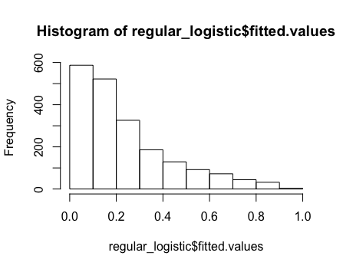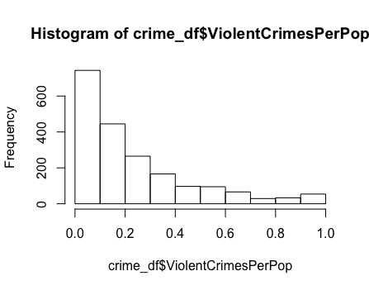

Ho = These two distributions are the same

Ha = These two distributions are different

Significance level = 0.05

**Simulation of null hypothesis ks statistic:**

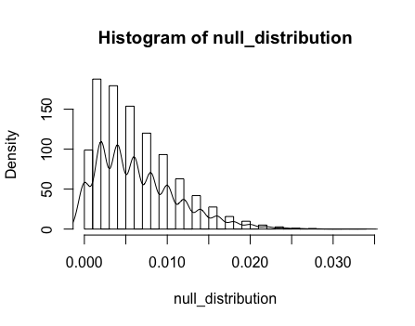

To generate our null hypothesis we simulate two subsamples from our sample set and find the ks statistic 10,000 times. Then we get the ks statistic from the two distributions we are testing. Our empirical p value is the average number of times the ks statistic from our simulation was less than that of the ks statistic in the distributions we are testing.

Our empirical p value was .0046 which is less than .05. We can reject the null and conclude that these two distributions are different.